
BRS Memberships
Member Functionality



TABLE OF CONTENTS

What is BRS Memberships? 3
Paying your bill 4
Full or Part Payment 4
Setting up Recurring Payments 5
Changing your card details 7
Topping Up Your Wallet 8
Viewing Wallet Transactions 9
Topping Up Your Competition Purse 10
Viewing Competition Purse Transactions 12

BRS MEMBERSHIPS

What is BRS Memberships?
BRS Memberships is a new membership management platform, developed by BRSGolf and GOLFNOW. This allows your golf club to administer manage member subscriptions, send out bills and manage payments online.
This document will guide you through the processes of viewing and paying your bill, signing up to a payment scheme and changing your bank card details.
The BRS Memberships system is available in both the BRS Members Booking Module and the APP which means that you can view and pay your bills in either.
Browser version looks like this: APP looks like this:
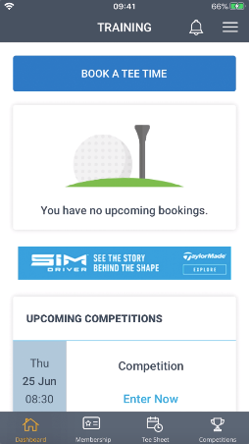
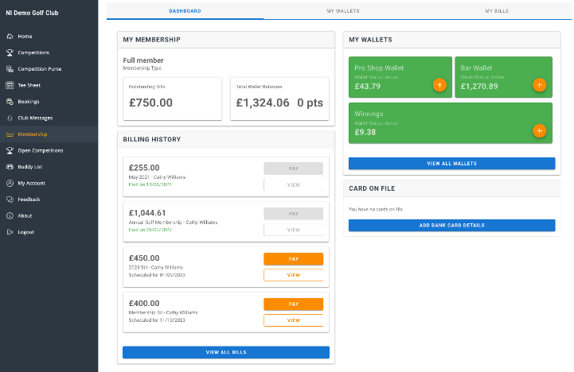

To see this, simply log in with your usual username and password.
When you choose the Membership option, you can see the dashboard which shows a summary of your membership, your billing history, wallets (if applicable) and card details.

Your Bill

Paying your bill
If you have a membership bill to pay you can view it in the dashboard. To see the details of the bill, choose the View option in the Billing History section.

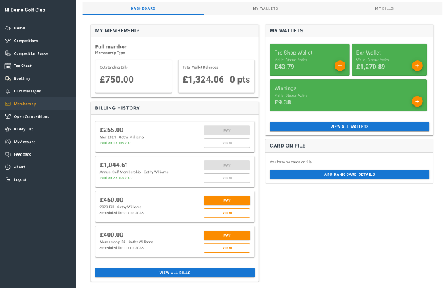
Browser:

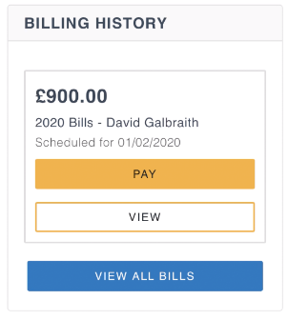
APP:

The bill details will show you the individual items included and the gross amount for each. From here you can pay your bill in full or in part or you may have the option to set up recurring payments.

Full or Part Payment
To pay your bill in full or in part, choose Pay.
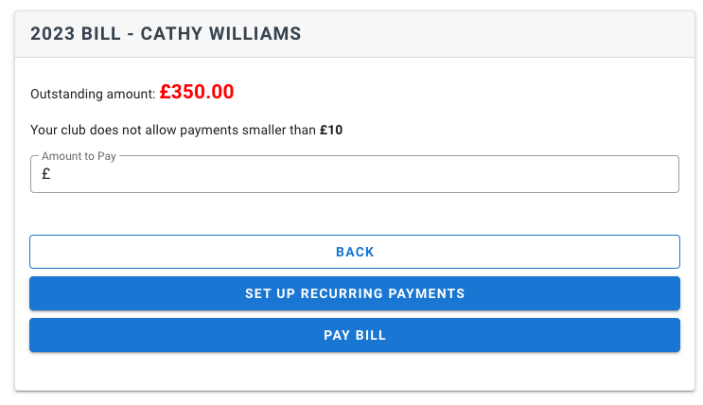

If your club allows, you can make a part payment by inputting the amount you wish to pay and choosing Pay Bill. If your club does not allow this, the Amount to Pay field will be set to the total amount for your bill.
Choose Pay Bill and complete the mandatory fields, marked with an * - these are required by Stripe to complete your payment. If your address details are stored in your BRS profile they will display here, otherwise complete the details.
Then complete your card number, expiry date and CVC number and choose Pay Bill. Also, you may be asked to input your postcode/Eircode.
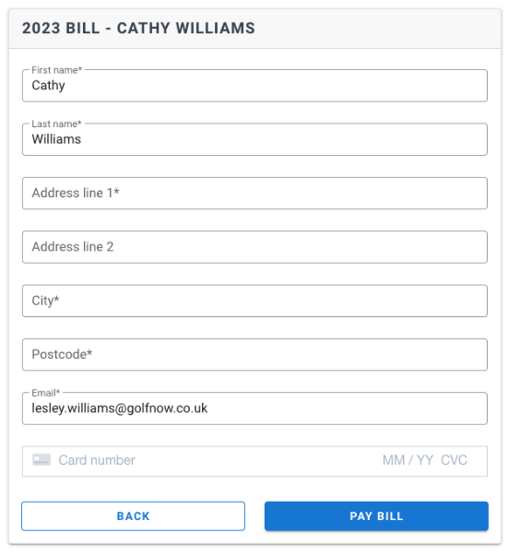

Setting up Recurring Payments
Your club may have enabled options to setup recurring payments for your bill. This will display on the Bill Details page as Set Up Recurring Payments.

You may have multiple schemes you can choose from. Open the list to view what schemes are available.
In Day of Month for Payment you can select the date that payments will be taken. Your golf club may have restricted this to specific date(s). When you select the date, the system will display each instalment, its due date and amount.
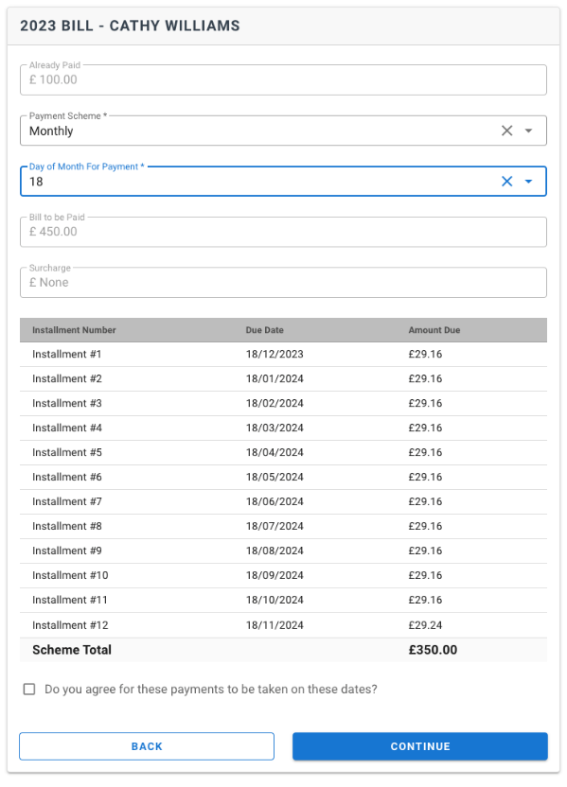
If there are alternative payment schemes, you can select a different one and the display will refresh to show you the revised instalments.
When you’re ready, tick to agree that payment can be take on these dates and choose Continue.
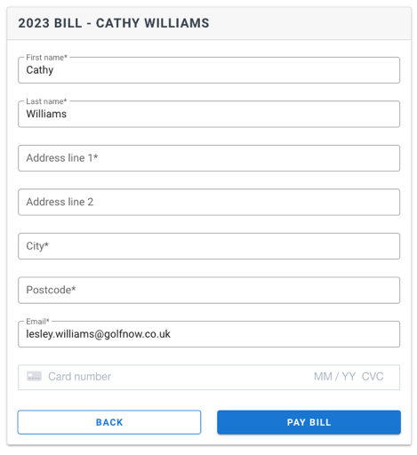

The instalments will be displayed in the My Bills section in Payment History. As each payment completes the status will change from Scheduled to Complete. Any payment that fails will display as failed, for example if your card details have expired this may result in a failed payment.
Should your scheduled payment fail you will receive an email to notify you. The system will attempt to take that scheduled payment every day for 5 days, if it continues to fail please contact your golf club.

CHANGING YOUR CARD DETAILS

Changing your card details
Once you have made a payment or signed up to a recurring payment, the card details that you input are stored in your Stripe customer record. NB. They are NOT stored in the BRS system and are NOT visible to anyone in your golf club.
The dashboard displays that you have card details on file

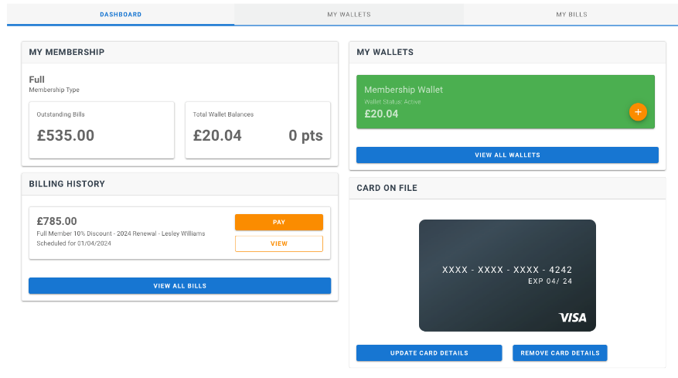
If you wish to change card details for any future payments or scheduled payments, simply choose Update Card Details and complete the form as before using your new card details.

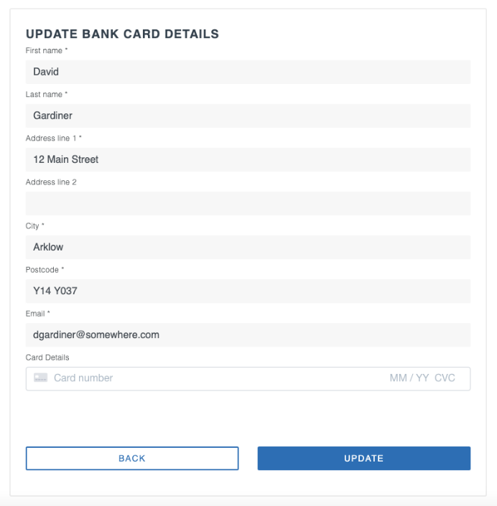

All future payments, including scheduled payments, will use the new card details.

TOPPING UP YOUR WALLET

Topping Up Your Wallet
If your club is using the BRS ePos system you may have one or more wallets that you can use to spend in the clubhouse bar, pro shop etc.
You can see the balance in your wallet(s) on the Dashboard page.

Browser version looks like this:

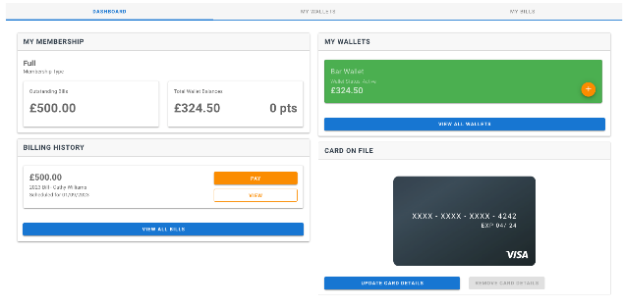
APP version looks like this:

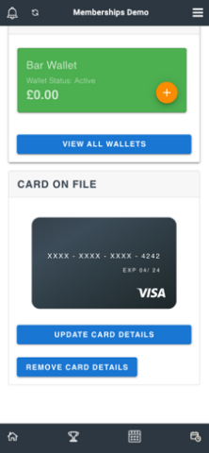

To add money to that wallet, click on the icon.
Then you can select the amount you want to top up or input the amount to top up.

Browser version looks like this:

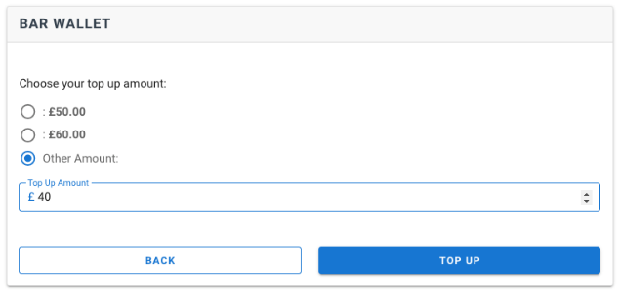

APP version looks like this:

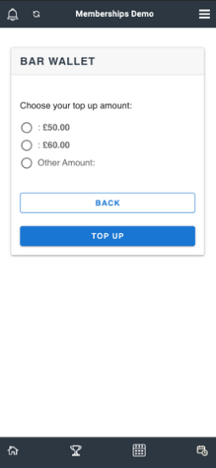
If you have card details in your profile when you click Top Up, the top up will complete and the funds will be added to your wallet.. If you do not have card details in your profile, you will be asked to complete the card details, as before.

Browser version looks like this:
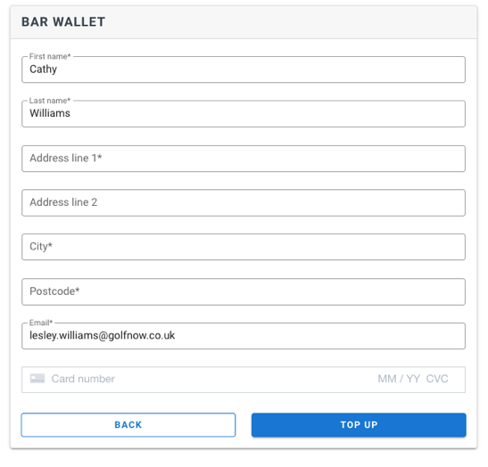

App version looks like this:

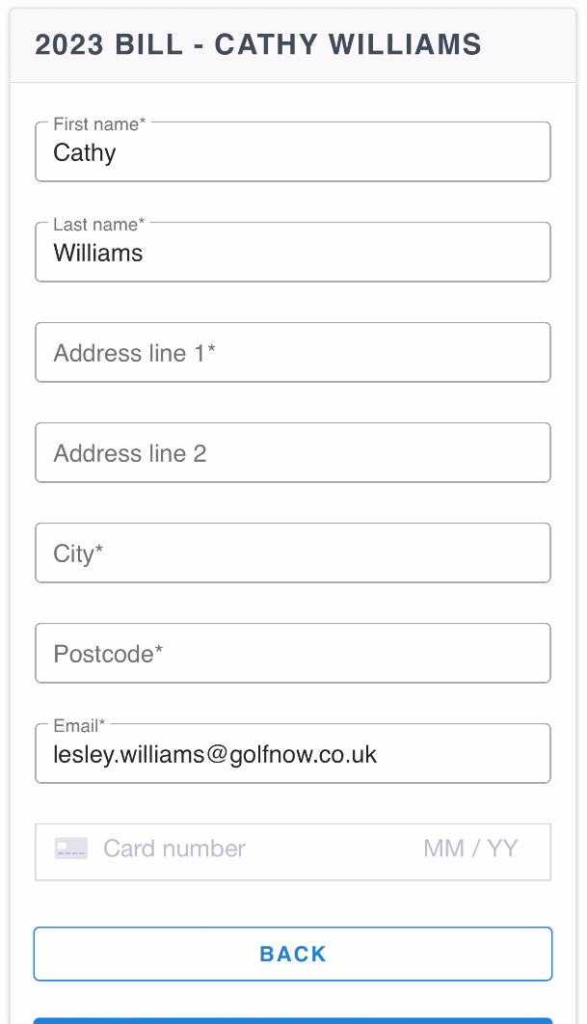
As this in an online payment, you will receive a notification from your banking app to confirm the payment. Once you’ve confirmed in your banking app, return to BRS and your payment will be completed.

VIEWING WALLET TRANSACTIONS

Viewing Wallet Transactions

If your club are using G1 ePOS then at any point you can view the transactions processed on your wallet. On the Dashboard page, go to My Wallets, or choose View All Wallets, from there you can see all transactions on all wallets or you can use the filter to select an individual wallet.

Browser version looks like this:

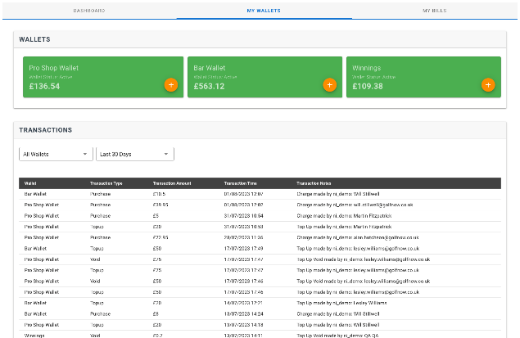

App version looks like this:
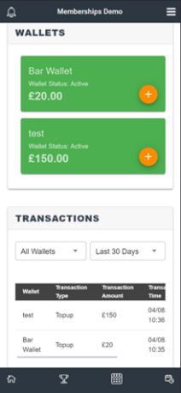

TOPPING UP YOUR COMPETITION PURSE

Topping Up Your Competition Purse
The Competition Purse is NOT to be confused with a Wallet. The Competition Purse is used solely to pay for your competition entries and is entirely separate from the wallet. Funds in the Competition Purse cannot be used to pay for goods in the clubhouse and vice versa, funds in your Wallet cannot be used to pay for your competition entry.

Your Competition Purse balance is visible on the Home page.

Browser version looks like this:
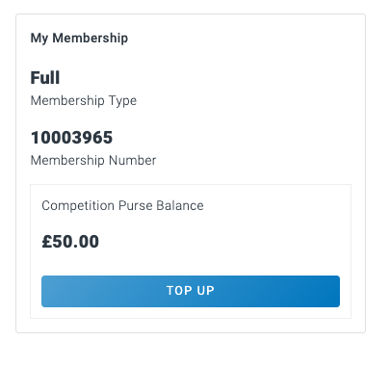
App version looks like this:
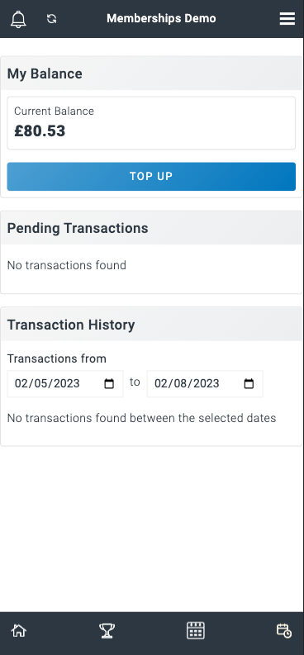
Click Top Up to add funds to your purse. You will be asked to select the amount you wish to top up by.

Browser version looks like this:

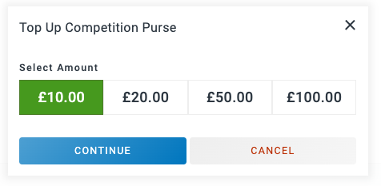
App version looks like this:
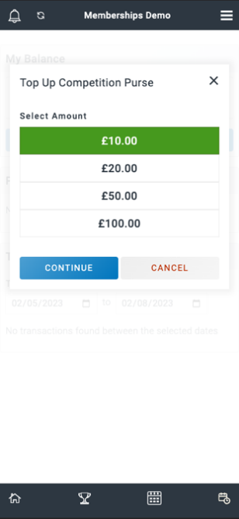
Then you will be asked to input your card details. Even if you have card details stored to use to pay your bill or top up your Wallet you will still be asked to input your card details.

Browser version looks like this:
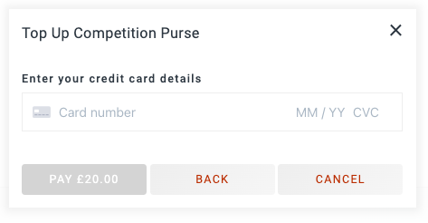
App version looks like this: 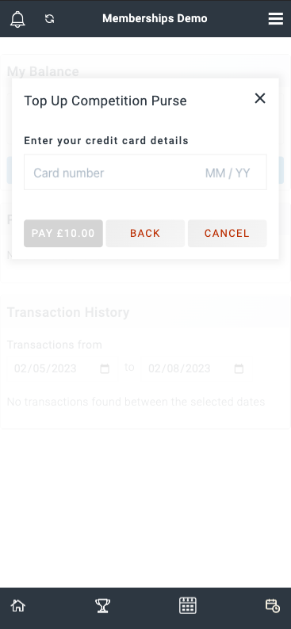

Once input your Competition Purse will be topped up with the amount you selected.

Viewing Competition Purse Transactions
At any point you can view the transactions processed on your competition purse. Select Competition Purse to view the individual transactions.

Browser version looks like this:
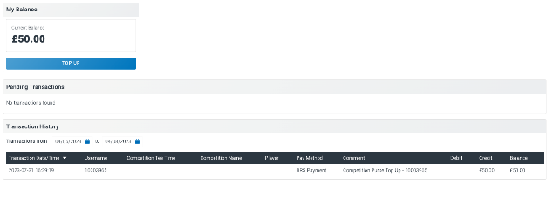
App version looks like this:
